Evidence Output

T002:

Valid modulus number.

Input number 138527.

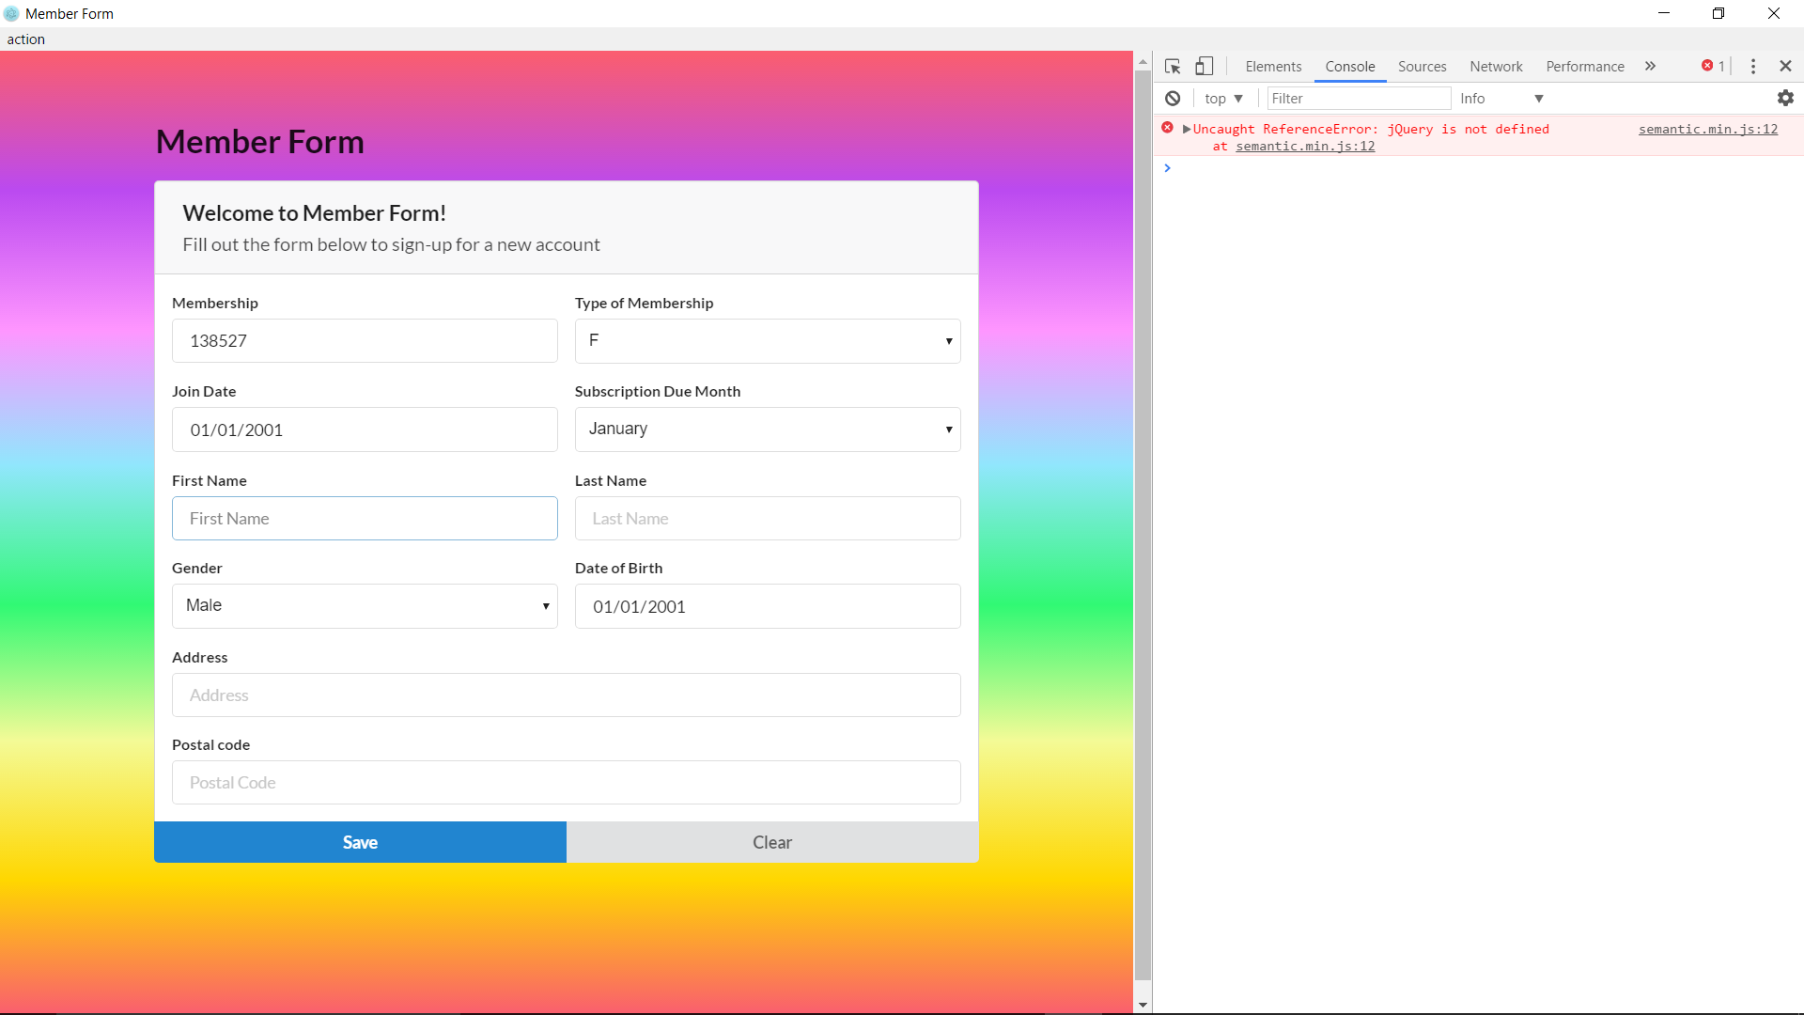

Membership number case valid fail.

